**Appendices G**

**Storyboard**

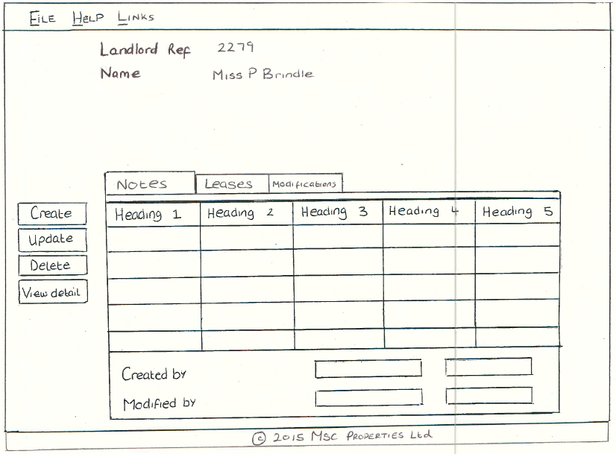

For the GUI implementation I would have used the below:

* JButtons for the Create, Update, Delete and View Details buttons. Also the use of Accelerator keys for the buttons to produce short cut keys.
* JTabbedPane to produce the Notes, Leases and Modification tabs
* Within each pane of the JTabbedPane, I would have a JTable, which would display the information from the Notes, Leases and Modifications lists in their own tab.
* JLabels for the LandlordRef, Name, CreatedBy and ModifiedBy, and for all 4 results, i.e 2279 and Miss P Brindle
* JMenuBar, with JMenu’s to produce the File, Help and Links menus, and add items to each of these menus. Also the use of Mnemonic keys to produce short cut keys.
* I would also place the tabbed pane, buttons and information area within their own panels (created in separate class, and use Actionisteners passed to them from the main panel in which these are added to, to reduce the coupling of the main frame and each of the components.

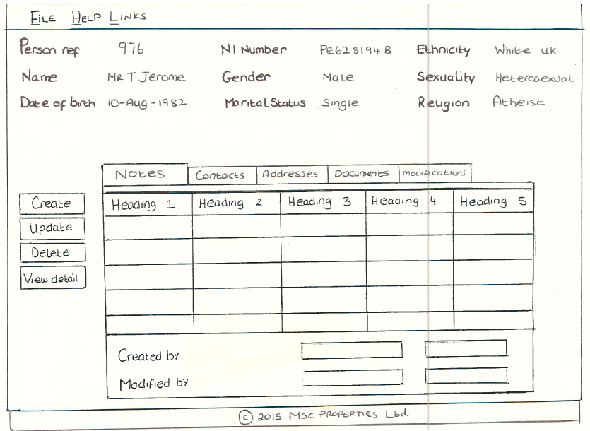

For the GUI implementation I would have used the below:

* JButtons for the Create, Update, Delete and View Details buttons. Also the use of Accelerator keys for the buttons to produce short cut keys.
* JTabbedPane to produce the Notes, Contact, Addresses, Documents and Modification tabs
* Within each pane of the JTabbedPane, I would have a JTable, which would display the information from the Notes, Contacts, Addresses, Documents and Modifications lists in their own tab.
* JLabels for the PersonRef, Name, CreatedBy, ModifiedBy, etc. and for each of the corresponding results, i.e 976 and Mr T Jerome.
* JMenuBar, with JMenu’s to produce the File, Help and Links menus, and add items to each of these menus. Also the use of Mnemonic keys to produce short cut keys.
* I would also place the tabbed pane, buttons and information area within their own panels (created in separate class, and use Actionisteners passed to them from the main panel in which these are added to, to reduce the coupling of the main frame and each of the components.

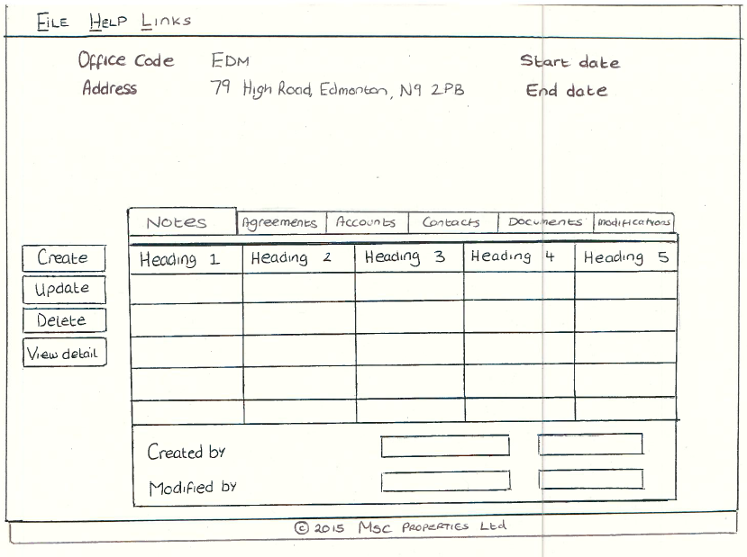

For the GUI implementation I would have used the below:

* JButtons for the Create, Update, Delete and View Details buttons. Also the use of Accelerator keys for the buttons to produce short cut keys.
* JTabbedPane to produce the Notes, Agreements, Accounts, Contacts, Documents and Modifications tabs.
* Within each pane of the JTabbedPane, I would have a JTable, which would display the information from the Notes, Agreements, Accounts, Contacts, Documents and Modifications lists in their own tab.
* JLabels for the OfficeCode, Address, CreatedBy, ModifiedBy, etc. and for each of the corresponding results, i.e EDM and 79 High Road….
* JMenuBar, with JMenu’s to produce the File, Help and Links menus, and add items to each of these menus. Also the use of Mnemonic keys to produce short cut keys.
* I would also place the tabbed pane, buttons and information area within their own panels (created in separate class, and use Actionisteners passed to them from the main panel in which these are added to, to reduce the coupling of the main frame and each of the components.

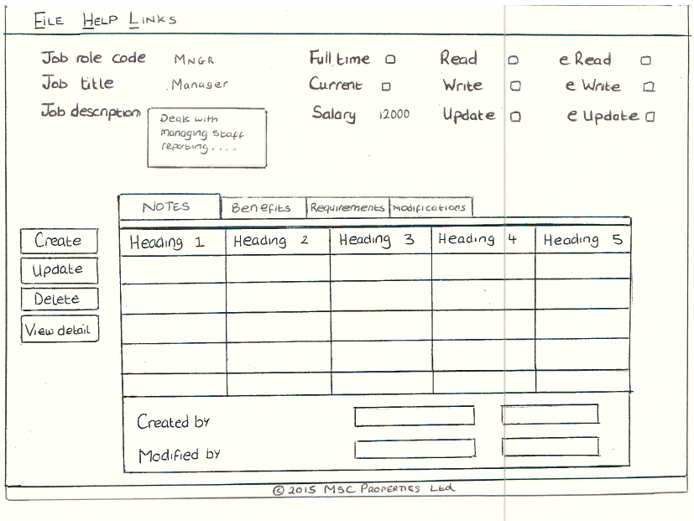

For the GUI implementation I would have used the below:

* JButtons for the Create, Update, Delete and View Details buttons. Also the use of Accelerator keys for the buttons to produce short cut keys.
* JTabbedPane to produce the Notes, Benefits, Requirements and Modifications tabs.
* Within each pane of the JTabbedPane, I would have a JTable, which would display the information from the Notes, Benefits, Requirements and Modifications lists in their own tab.
* JLabels for the JobRoleCode, JobTitle, CreatedBy, ModifiedBy, etc. and for each of the corresponding results, i.e MNGR and Manager.
* JMenuBar, with JMenu’s to produce the File, Help and Links menus, and add items to each of these menus. Also the use of Mnemonic keys to produce short cut keys.
* I would also place the tabbed pane, buttons and information area within their own panels (created in separate class, and use Actionisteners passed to them from the main panel in which these are added to, to reduce the coupling of the main frame and each of the components.

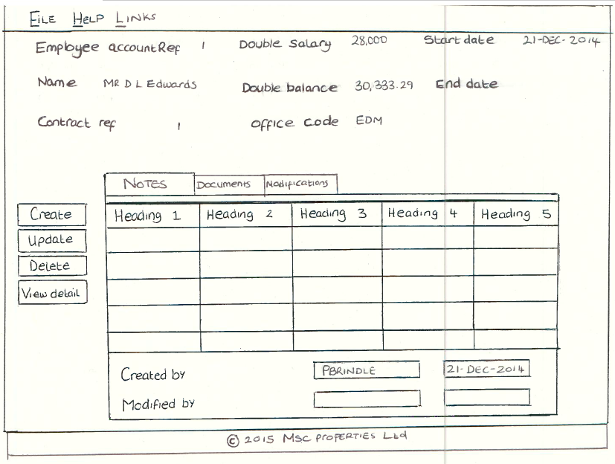

For the GUI implementation I would have used the below:

* JButtons for the Create, Update, Delete and View Details buttons. Also the use of Accelerator keys for the buttons to produce short cut keys.
* JTabbedPane to produce the Notes, Documents, Transactions and Modifications tabs.
* Within each pane of the JTabbedPane, I would have a JTable, which would display the information from the Notes, Documents Transactions and Modifications lists in their own tab.
* JLabels for the Name, Salary, Balance, CreatedBy, ModifiedBy, etc. and for each of the corresponding results, i.e MR D L Edwards or 28,000.
* JMenuBar, with JMenu’s to produce the File, Help and Links menus, and add items to each of these menus. Also the use of Mnemonic keys to produce short cut keys.
* I would also place the tabbed pane, buttons and information area within their own panels (created in separate class, and use Actionisteners passed to them from the main panel in which these are added to, to reduce the coupling of the main frame and each of the components.

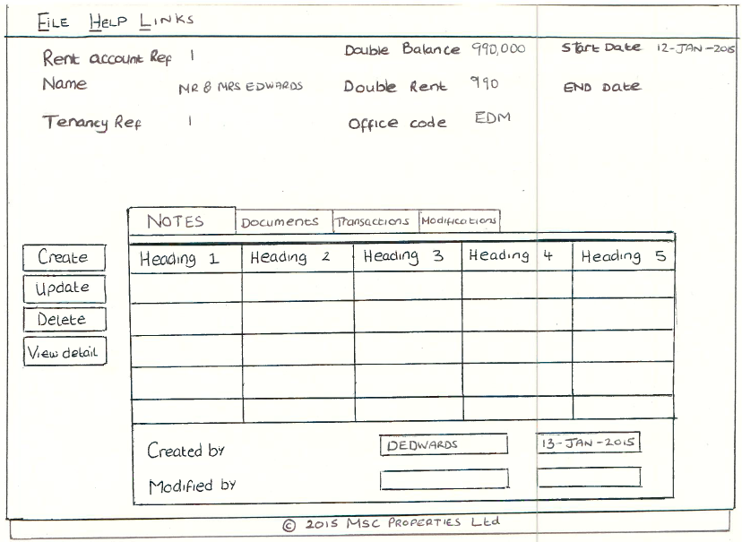

For the GUI implementation I would have used the below:

* JButtons for the Create, Update, Delete and View Details buttons. Also the use of Accelerator keys for the buttons to produce short cut keys.
* JTabbedPane to produce the Notes, Documents, Transactions and Modifications tabs.
* Within each pane of the JTabbedPane, I would have a JTable, which would display the information from Notes, Documents, Transactions and Modifications lists in their own tab.
* JLabels for the TenancyRef, Balance, CreatedBy, ModifiedBy, etc. and for each of the corresponding results, i.e MNGR and Manager.
* JMenuBar, with JMenu’s to produce the File, Help and Links menus, and add items to each of these menus. Also the use of Mnemonic keys to produce short cut keys.
* I would also place the tabbed pane, buttons and information area within their own panels (created in separate class, and use Actionisteners passed to them from the main panel in which these are added to, to reduce the coupling of the main frame and each of the components.

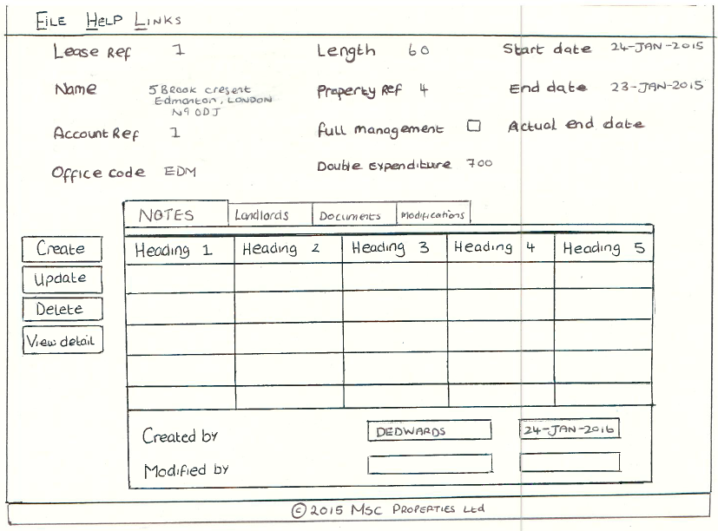

For the GUI implementation I would have used the below:

* JButtons for the Create, Update, Delete and View Details buttons. Also the use of Accelerator keys for the buttons to produce short cut keys.
* JTabbedPane to produce the Notes, Landlords, Documents and Modifications tabs.
* Within each pane of the JTabbedPane, I would have a JTable, which would display the information from the Notes, Landlords, Documents and Modifications lists in their own tab.
* JLabels for the Length, PropertyRef, CreatedBy, ModifiedBy, etc. and for each of the corresponding results, i.e MNGR and Manager.
* JMenuBar, with JMenu’s to produce the File, Help and Links menus, and add items to each of these menus. Also the use of Mnemonic keys to produce short cut keys.
* I would also place the tabbed pane, buttons and information area within their own panels (created in separate class, and use Actionisteners passed to them from the main panel in which these are added to, to reduce the coupling of the main frame and each of the components.

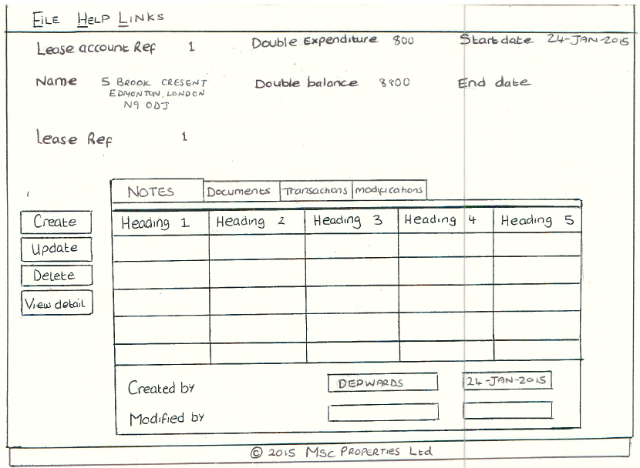

For the GUI implementation I would have used the below:

* JButtons for the Create, Update, Delete and View Details buttons. Also the use of Accelerator keys for the buttons to produce short cut keys.
* JTabbedPane to produce the Notes, Documents, Transactions and Modifications tabs.
* Within each pane of the JTabbedPane, I would have a JTable, which would display the information from Notes, Documents, Transactions and Modifications lists in their own tab.
* JLabels for the Name, Balance, CreatedBy, ModifiedBy, etc. and for each of the corresponding results, i.e 800 and 8,800.
* JMenuBar, with JMenu’s to produce the File, Help and Links menus, and add items to each of these menus. Also the use of Mnemonic keys to produce short cut keys.
* I would also place the tabbed pane, buttons and information area within their own panels (created in separate class, and use Actionisteners passed to them from the main panel in which these are added to, to reduce the coupling of the main frame and each of the components.

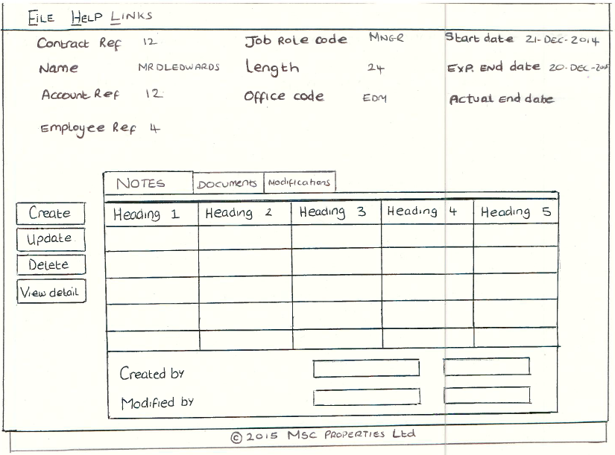

For the GUI implementation I would have used the below:

* JButtons for the Create, Update, Delete and View Details buttons. Also the use of Accelerator keys for the buttons to produce short cut keys.
* JTabbedPane to produce the Notes, Documents and Modifications tabs.
* Within each pane of the JTabbedPane, I would have a JTable, which would display the information from the Notes, Documents and Modifications lists in their own tab.
* JLabels for the Length, ContractRef, CreatedBy, ModifiedBy, etc. and for each of the corresponding results, i.e MNGR and Manager.
* JMenuBar, with JMenu’s to produce the File, Help and Links menus, and add items to each of these menus. Also the use of Mnemonic keys to produce short cut keys.
* I would also place the tabbed pane, buttons and information area within their own panels (created in separate class, and use Actionisteners passed to them from the main panel in which these are added to, to reduce the coupling of the main frame and each of the components.

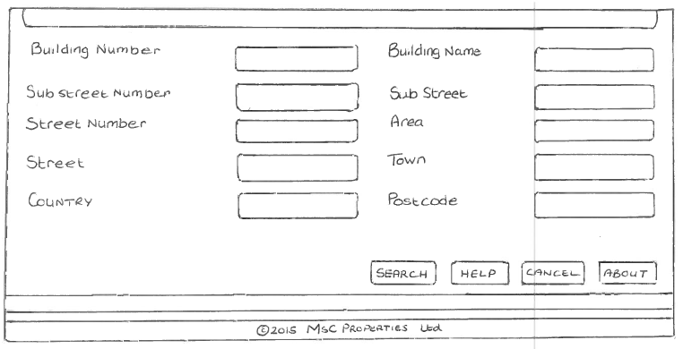

For the GUI implementation I would have used the below:

* JButtons for the Search, Help, Cancel and About button
* JLabels for the BuildingName, Area, SubStreet, Town, etc.
* JTextFields, for the boxes to enter details into the form

Additionally, to the above GUI’s I would need to produce a number of screens for the data entry to create people, applications, properties, etc. To do this would use drop down boxes for elements such as property sub type, or person title, which would invoke the Client.getCurrentTitles() method or Client.getCurrentPropSubTypes(), which would return a list of elements that would need to then be loaded in to the combo box for the client to select, this then ensures that the client can only select data from the system which is correct, which increases the systems robustness, as the client is unable to enter data that would not allow for the object to be created.

Furthermore, on the above display screens, the client GUI would invoke methods such as Property.getPropRef() or Property.getPropSubType() to enable the display screens to display the remote object information.